**CIS355**

**How to use MySQL Inside Azure   
DeVry University  
College of Engineering and Information Sciences**

Preparation (has to be done before you start working on your query)

1. Login to your VM and open MySQLWorkbench.

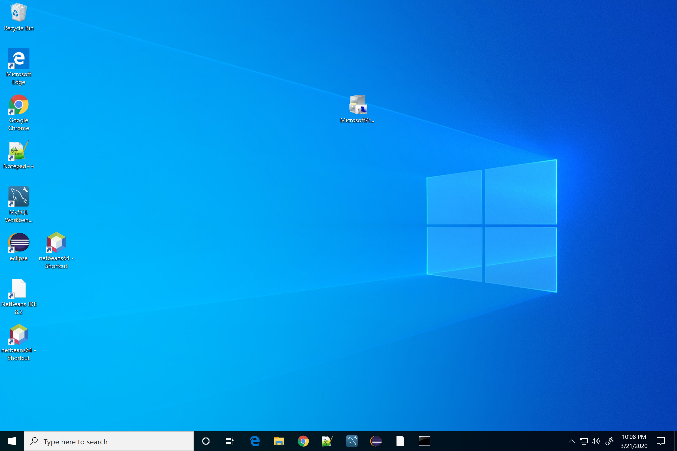

Click MySQL Workbench

1. Close the welcome screen. Double-click on the local instance.

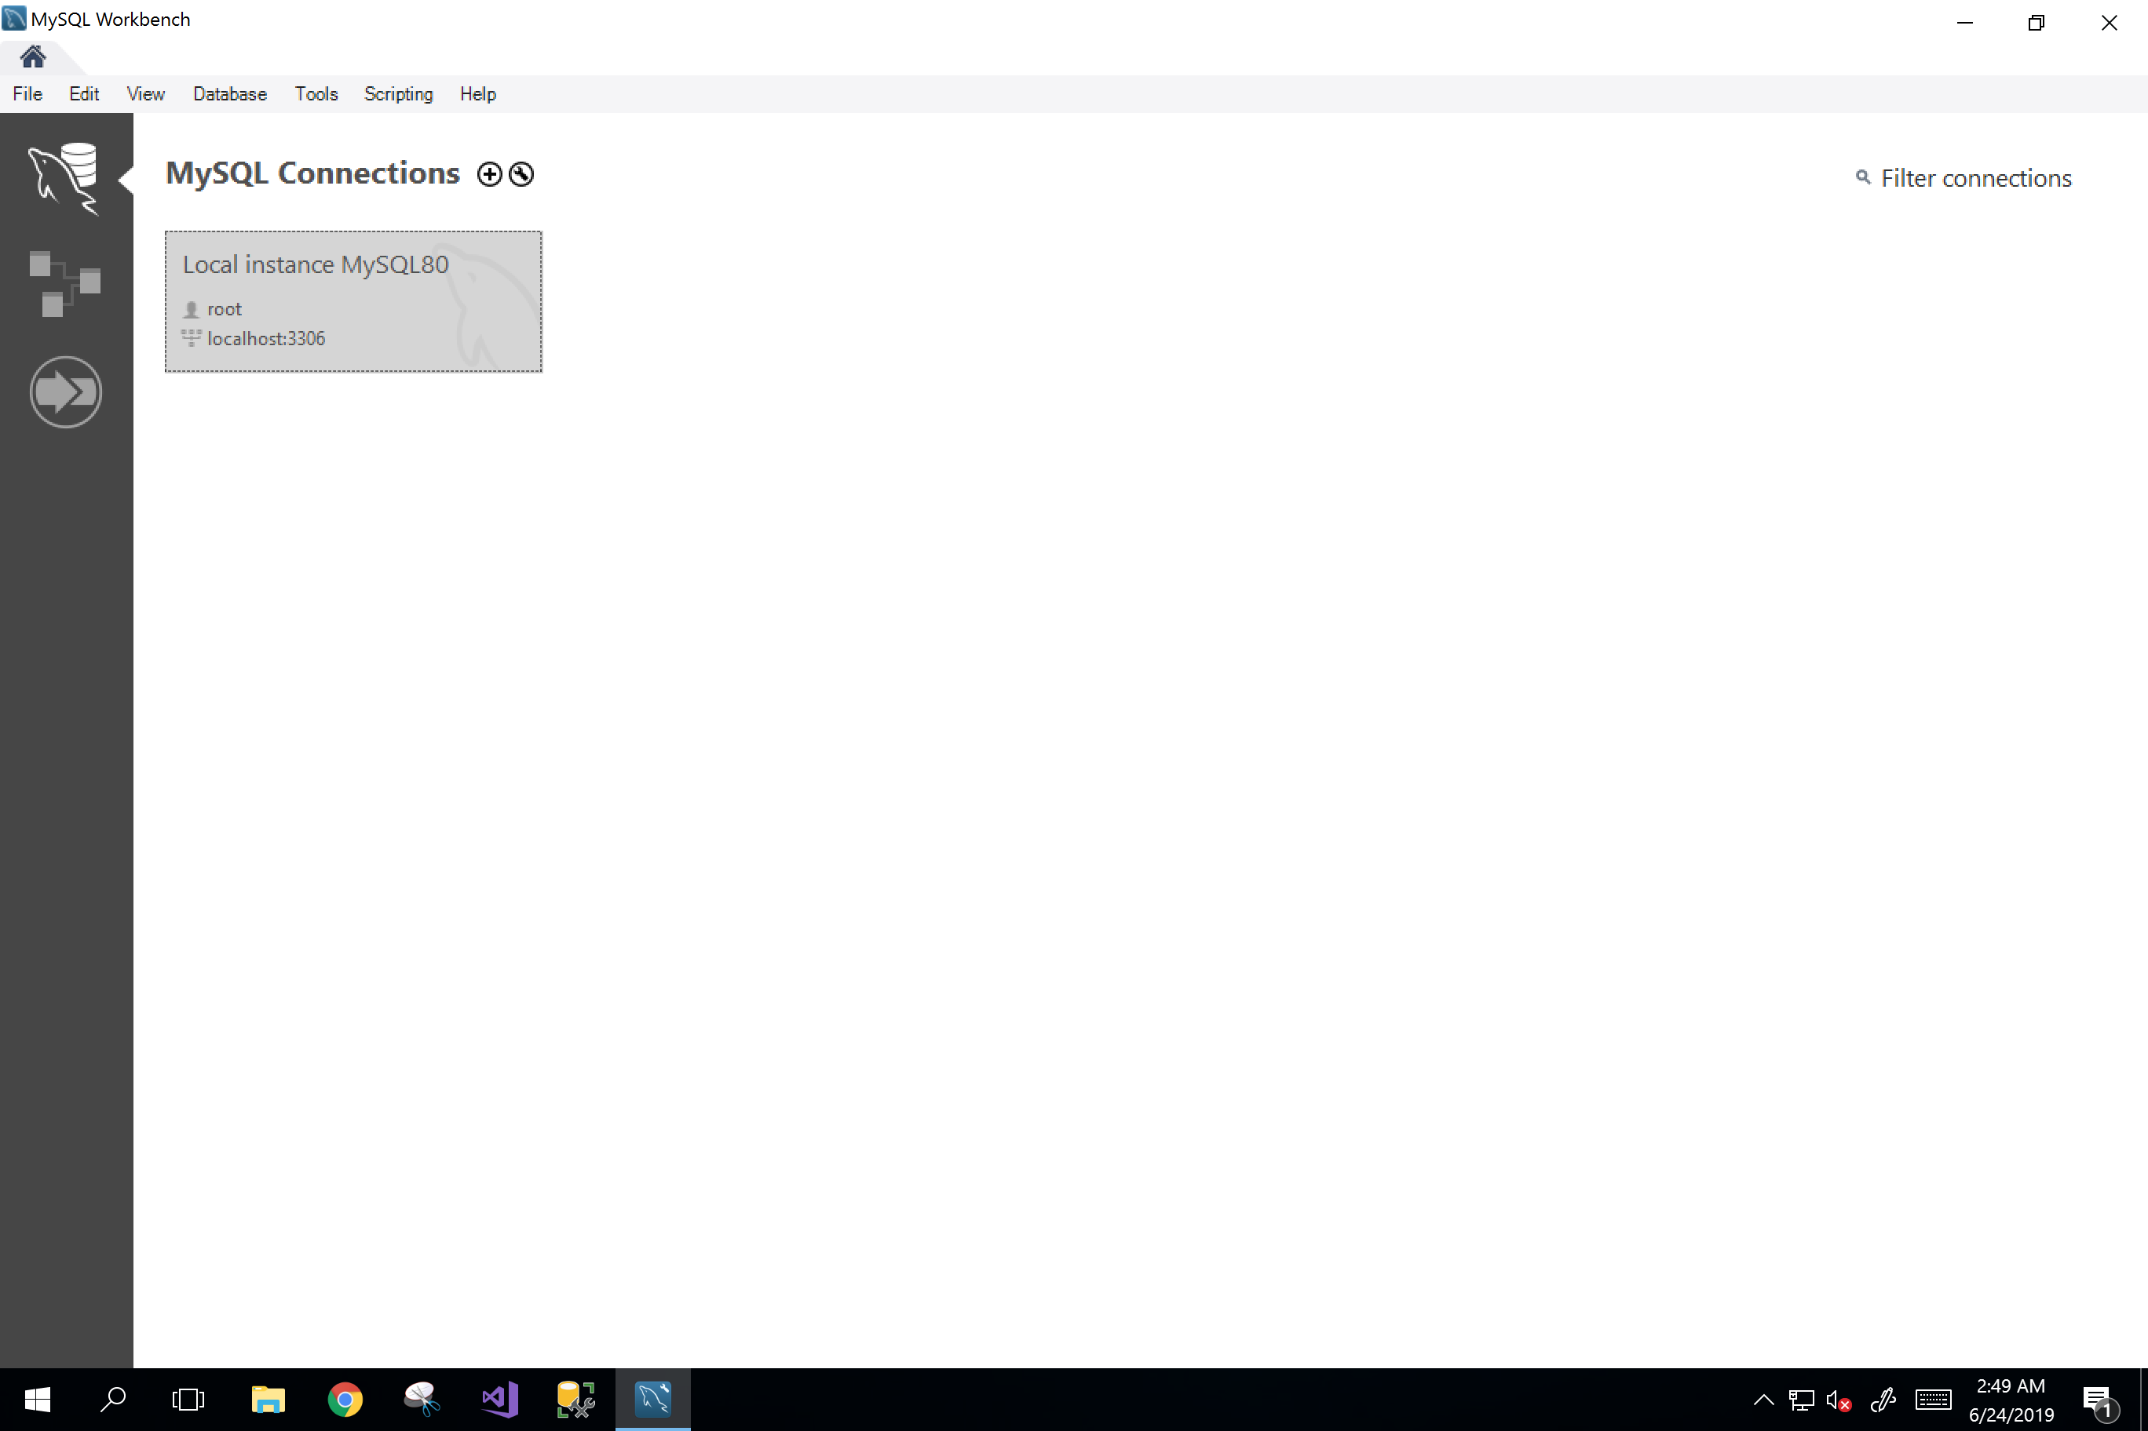

Click this.

1. Enter password **devry123.**

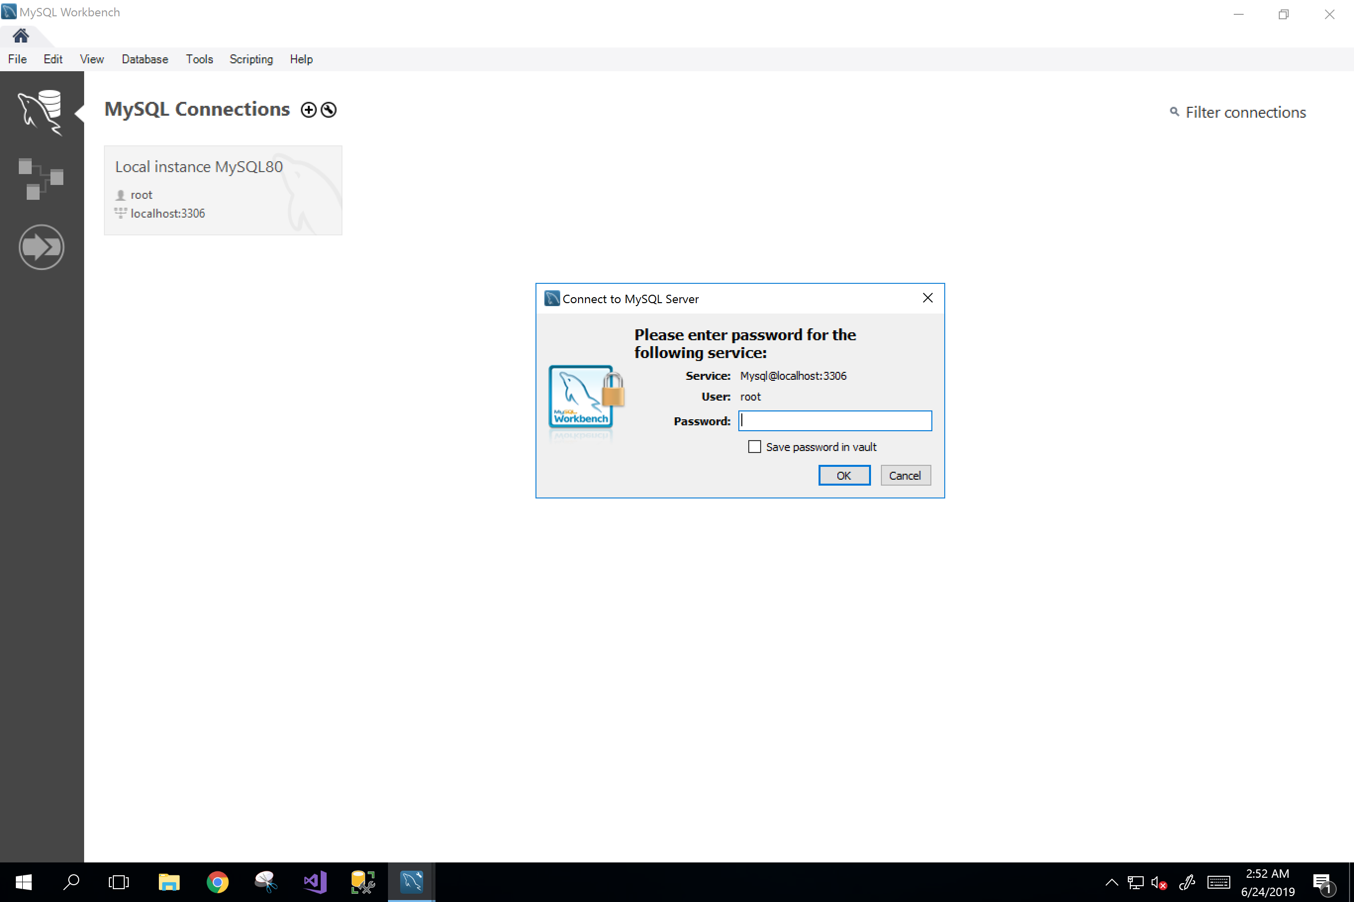

devry123

1. You are now inside your SQL editor and ready to create a new SQL schema (database). Click on the fourth icon to create a new schema.

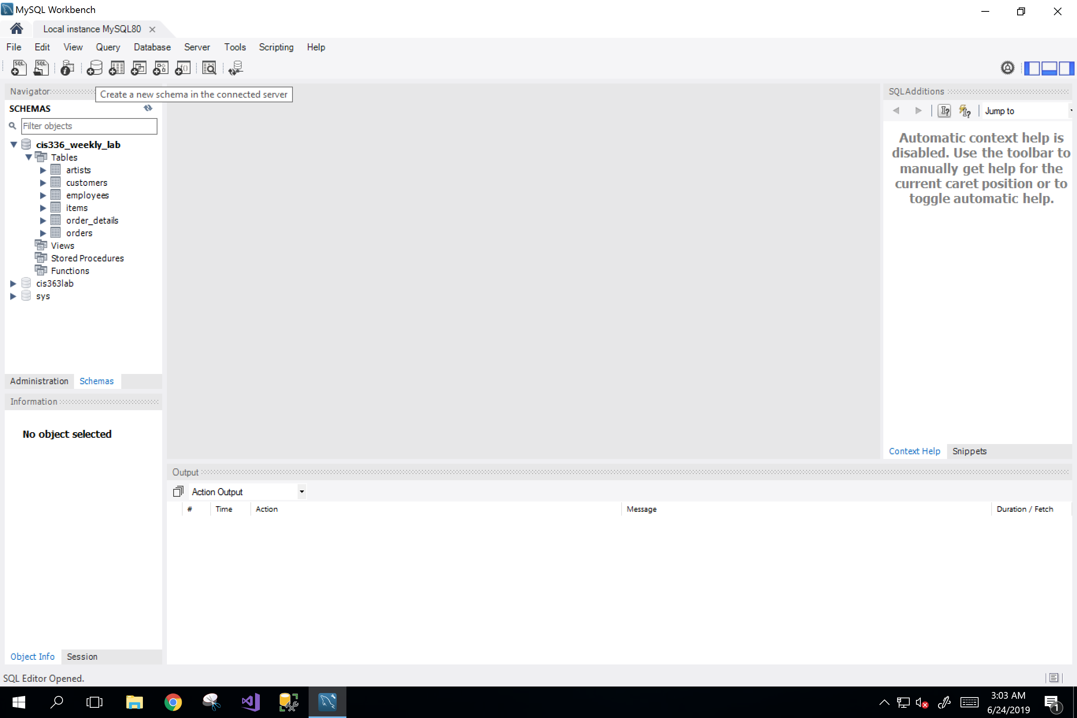

Click the fourth icon to create a new schema.

1. When the window pops out, name your schema, then click Apply.

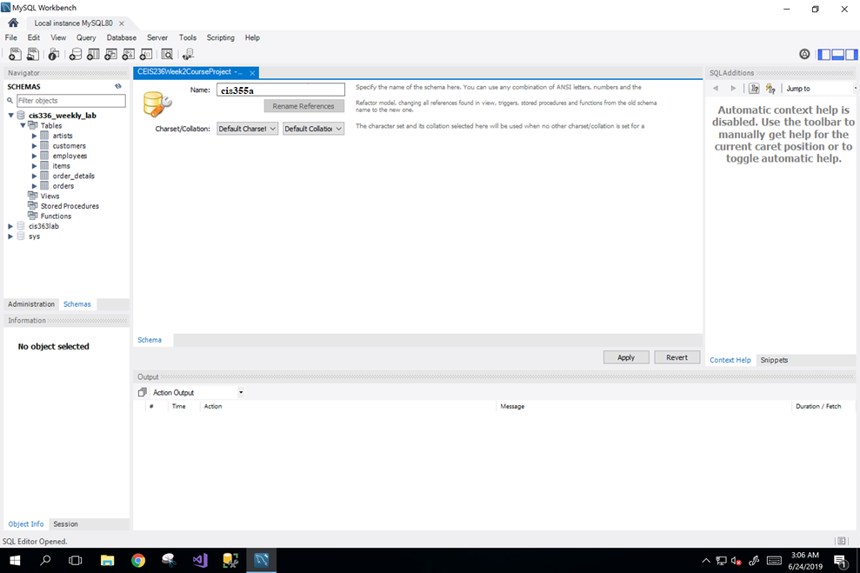

Name your schema here.

1. On the next review SQL script window, click Apply again.

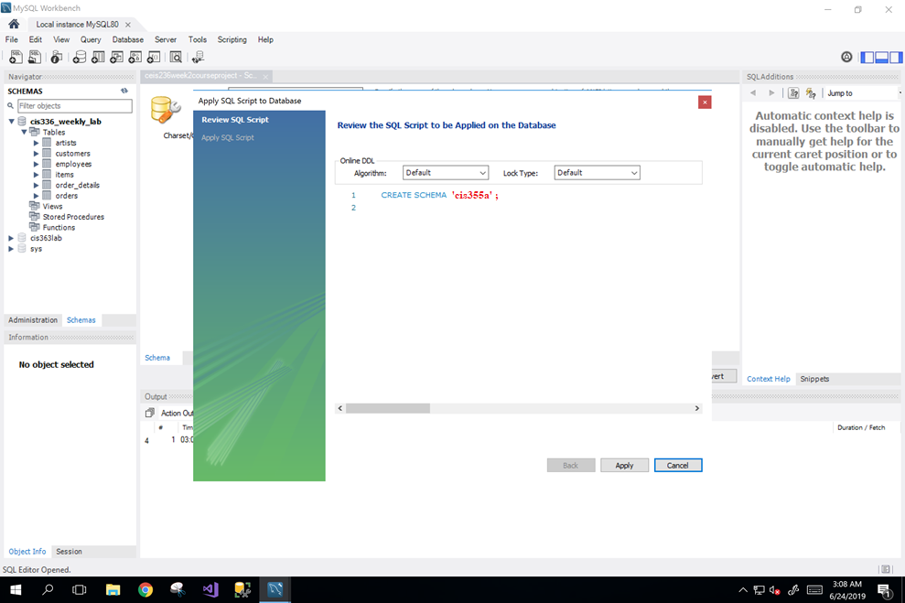

Click

1. On the next applying page, click Finish.

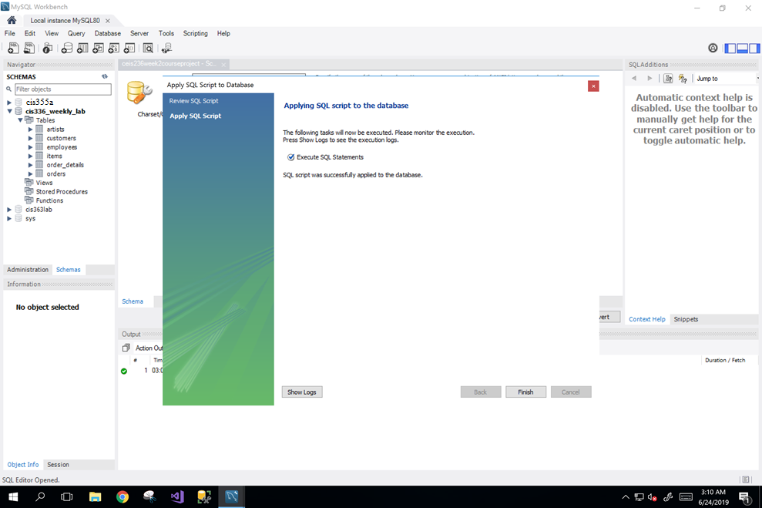

Click

1. On your navigator window, you can now see your newly created schema.

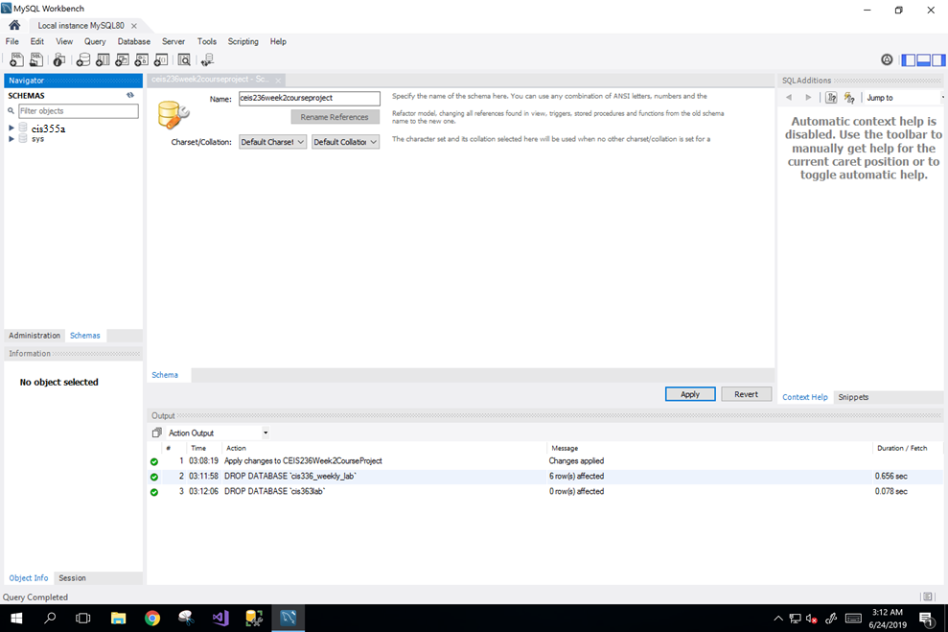

Verify that your schema is created.

1. Click the first icon to create a new SQL tab for executing queries.



Click

1. Now we have the SQL editor ready for executing queries. Let‘s make sure we are working under the default schema. Right-click the schema to set it as default schema.

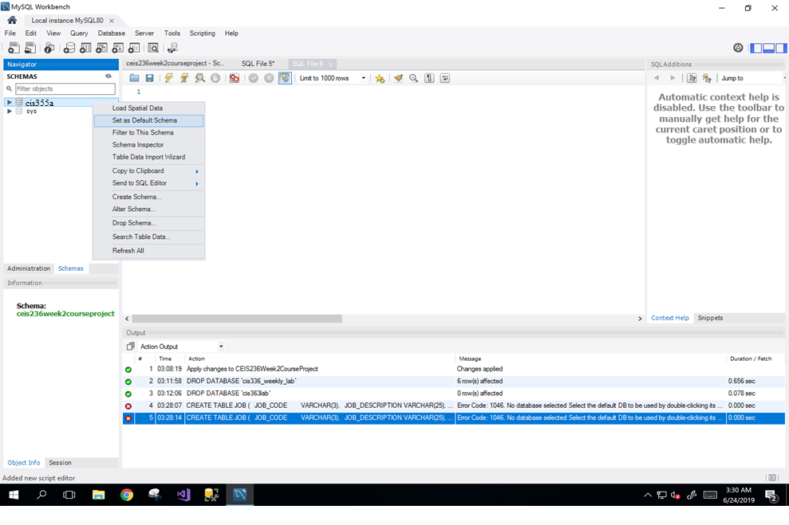

Set default schema first.

1. Now you are ready to write queries into the SQL editor window.
2. Execute the script by clicking the symbol 

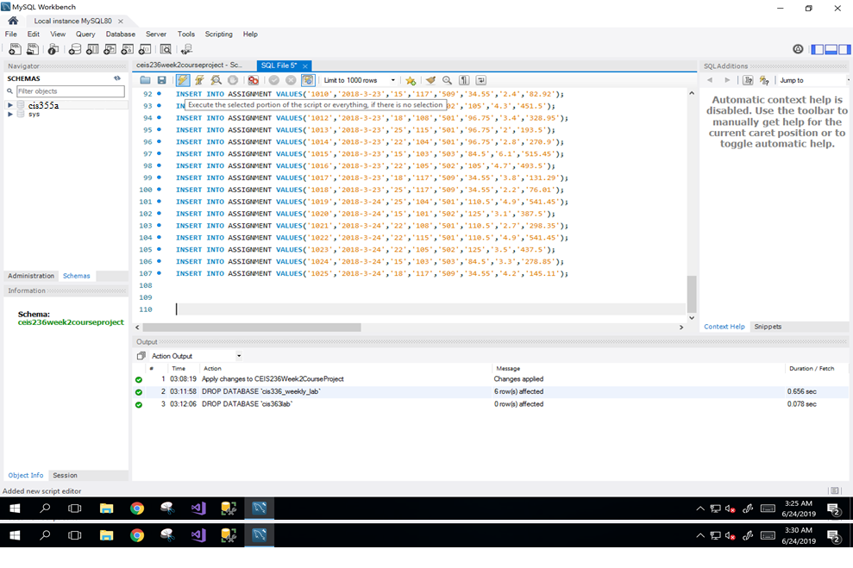

Click